High Scores
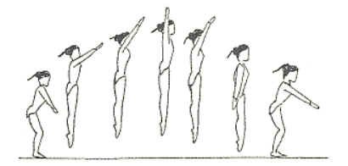

The 5 judges scored the competitors in the school trampolining competition as follows

Competitor 1
Judge | 1 | 2 | 3 | 4 | 5
score | 6.8 | 7.1 | 8.3 | 7.2 | 6.7

Competitor 2
Judge | 1 | 2 | 3 | 4 | 5
score | 7.4 | 7.2 | 7.3 | 7.2 | 6.8

Competitor 3
Judge | 1 | 2 | 3 | 4 | 5
score | 6.8 | 6.7 | 6.8 | 8.3 | 8.2

Competitor 4
Judge | 1 | 2 | 3 | 4 | 5
score | 7.0 | 7.5 | 7.6 | 6.5 | 7.4

Competitor 5
Judge | 1 | 2 | 3 | 4 | 5
score | 6.1 | 6.9 | 6.8 | 6.6 | 6.7

Who is the winner?

High Scores

Trampolining Scoring System

- When there are five judges you can add all the scores together and then find the average score [ s₁ + s₂ + s₃ + s₄ + s₅]
5

- or usually the highest and lowest score are removed and then the remaining three scores are used [s₂ + s₃ + s₄]
3
– How does this affect the positions?
  - Work out the result if all 5 judges scores are used
  - Work out the result if the highest and lowest score are removed

- However this is the final round of the competition and the five competitors have completed a voluntary programme on the trampoline (that means that they have decided the content and the difficulty). The judges decide and award the level of difficulty which is used to multiply the final scores.
The levels of difficulty awarded were –
- Competitor 1 – Level of difficulty 1.25
- Competitor 2 – Level of difficulty 1.2
- Competitor 3 – Level of difficulty 1.15
- Competitor 4 – Level of difficulty 1.2
- Competitor 5 – Level of difficulty 1.3

Use this formula to find out the new positions of the trampolinists
d[s₂ + s₃ + s₄]
5
Where d is the level of difficulty
and s₁ the score from lowest scoring judge

